Appendix

The Merits of Mobile Instant Messaging for EFL Learners: Learning Engagement, Achievement, and Authentic Relationships

David Imamyartha, Universitas Jember, Jember, East Java, Indonesia & Universitas Negeri Malang, Malang, East Java, Indonesia

Utami Widiati, Universitas Negeri Malang, Malang, East Java, Indonesia

M. Zaini Miftah, Universitas Negeri Malang, Malang, East Java, Indonesia & Institut Agama Islam Negeri Palangka Raya, Central Kalimantan, Indonesia

Figures 2-11
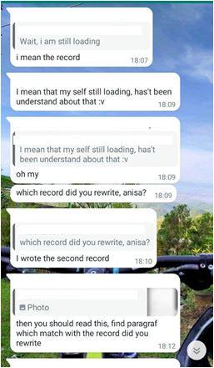
Figure 2: Student hardly grasped task procedure

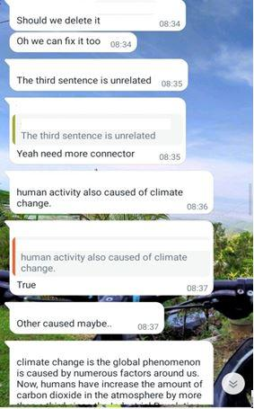

Figure 3: Students discussed text coherence | Figure 4: A student expressed her embarrassment.
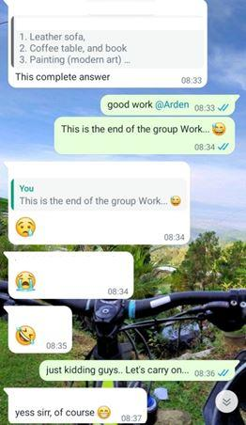
Figure 5: The teacher teased the students on one member sharing complete answers

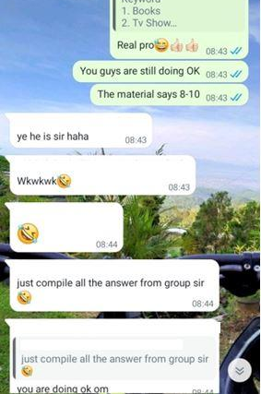 | 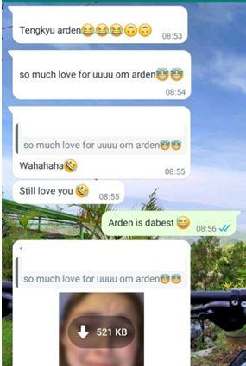
Figure 6: The teacher shared the feedback to the group work | Figure 7: Students teased a peer for his dominant contribution
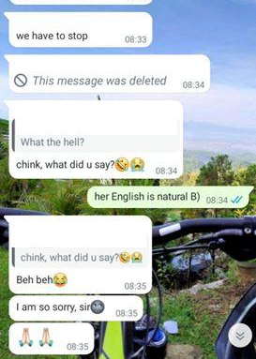
Figure 8: A student accidentally used a swear word

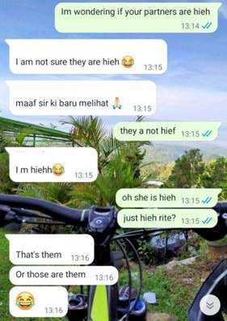 | 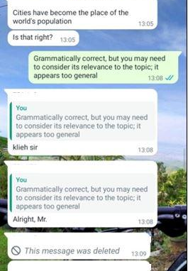
Figure 9: The teacher checked students’ presence | Figure 10: A student requested confirmation
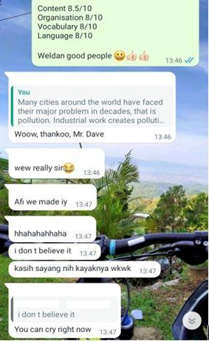

Figure 11: Students expressed excitement about their achievement

