Appendix A. Pronunciation Diagnostic Test

Note: This is a sample instrument given to advanced level students. The instruments were tailored for each of the three levels based on the problems predicted by CAH. The words and sounds in bold font were areas that we predicted would be problematic, and which we used in our analysis at segmental and suprasegmental levels. However, the version we gave to students was a “clean” copy with no markings.

Part I: Reading
Read the following passage out loud:

The Fall of the House of Usher, by Edgar Allan Poe

During the whole of a dull, dark, and soundless day in the autumn of the year, when the clouds hung oppressively low in the heavens, I had been passing alone, on horseback, through a singularly dreary tract of country; and at length found myself, as the shades of the evening drew on, within view of the melancholy House of Usher. I know not how it was--but, with the first glimpse of the building, a sense of insufferable gloom pervaded my spirit. I say insufferable; for the feeling was unrelieved by any of that half-pleasurable, because poetic, sentiment, with which the mind usually receives even the sternest natural images of the desolate or terrible. I looked upon the scene before me--upon the mere house, and the simple landscape features of the domain--upon the bleak walls--upon the vacant eye-like windows--upon a few rank sedges--and upon a few white trunks of decayed trees--with an utter depression of soul which I can compare to no earthly sensation more properly than to the after-dream of the reveler upon opium--the bitter lapse into everyday life-the hideous dropping off of the reveler upon opium--the bitter lapse into everyday life--the hideous dropping off of the veil. There was an iciness, a sinking, a sickening of the heart--an unredeemed dreariness of thought which no goading of the imagination could torture into aught of the sublime. What was it--I paused to think--what was it that so unnerved me in the contemplation of the House of Usher? It was a mystery all insoluble; nor could I grapple with the shadowy fancies that crowded upon me as I pondered. I was forced to fall back upon the unsatisfactory conclusion, that while, beyond doubt; there are combinations of very simple natural objects which have the power of thus affecting us, still the analysis of this power lies among considerations beyond our depth. It was possible, I reflected, that a mere different arrangement of the particulars of the scene, of the details of the picture, would be sufficient to modify, or perhaps to annihilate its capacity for sorrowful impression; and, acting upon this idea, I reined my horse to the precipitous brink of a black and lurid tarn that lay in unruffled luster by the dwelling, and gazed down--but with a shudder even more thrilling than before--upon the remodeled and inverted images of the gray sedge, and the ghastly tree-stems, and the vacant and eye-like windows.
Source: http://www.englishclub.com/reading/story-house-of-usher.htm

Read out loud the following dialogue:

Police Officer: Hello. 24th Precinct. Officer Jones speaking.
Man: Help. Yeah, uh, it was wild, I mean really bizarre.
Police Officer: Calm down sir! Now, what do you want to report?
Man: Well, I'd like to report a UFO sighting.
Police Officer: A what?
Man: What do you mean "what?" An unidentified flying object!
Police Officer: Wait, tell me exactly what you saw.
Man: Well, I was driving home from a party about three hours ago, so it was about 2:00 AM, when I saw this bright light overhead.
Police Officer: Okay. And then what happened?
Man: Oh, man. Well, it was out of this world. I stopped to watch the light when it disappeared behind a hill about a kilometer ahead of me.
Police Officer: Alright. Then what?
Man: Well, I got back in my car and I started driving toward where the UFO landed.
Police Officer: Now, how do you know it was a UFO? Perhaps you only saw the lights of an airplane [No], or the headlights of an approaching car [No]. Things like that happen, you know.
Man: Well if it was that, how do you explain "the BEAST"?
Police Officer: What do you mean, "the BEAST"?
Man: Okay. I kept driving for about five minutes when all of a sudden, this giant, hairy creature jumped out in front of my car.
Police Officer: Oh, yeah. Then what?
Man: Well, then, the beast picked up the front of my car and said, "Get out of the car. I'm taking you to my master!" Something like that.
Police Officer: Wow? A hairy alien who can speak English! Come on!
Man: I'm not making this up, if that's what you're suggesting. Then, when I didn't get out of the car, the beast opened the car door, carried me on his shoulders to this round-shaped flying saucer, and well, that's when I woke up alongside the road. The beast must have knocked me out and left me there.
Police Officer: Well, that's the best story I've heard all night, sir. Now, have you been taking any medication, drugs, or alcohol in the last 24 hours? You mentioned you went to a party.
Man: What? Well, I did have a few beers, but I'm telling the truth.
Police Officer: Okay, okay. We have a great therapist that deals with THESE kinds of cases.
Man: I'm not crazy.
Police Officer: Well, we'll look into your story. Thank you.
Source: http://www.esl-lab.com/story1/storysc1.htm

Part II: Minimal Pairs

Read each pair of words and sentences out loud:
1 | beat | bit, lead | lead |  |  | Please sit in this seat.
2 | beat | bait, pay | pea |  |  | I hate this heat.
3 | bet | bet, mean | men |  |  | The step is steep.
4 | bit | bait, give | gave |  |  | The pill made her pale.
5 | lid | led, left | lift |  |  | He hid his head.
6 | bag | bag, dish | dash |  |  | Give the ham to him.
7 | rib | rub, did | did |  |  | That bug is big.
8 | lace | less, gate | get |  |  | Don't let them be late.
9 | made | mad, past | past |  |  | I hate this hat.
10 | but | but, sum | same |  |  | They run in the rain.
11 | raid | road, cone | cane |  |  | Please taste the toast.
12 | head | had, mass | mess |  |  | This bed is bad.
13 | three | though, they | throw |  |  | They threw the ball.
14 | leg | log, stop | step |  |  | The rod was red.
15 | tug | tug, cup | cap |  |  | My hat is in that hut.
16 | rack | rock, tap | top |  |  | She sang a song.
17 | hide | had, I'm | am |  |  | Put back my bike.
18 | done | done, suck | sock |  |  | I hope that's not a nut.
19 | stud | stood, put | put |  |  | This book cost a buck.
20 | rum | roam, nut | note |  |  | He must have the most.
21 | sun | sawn, boss | bus |  |  | My gun is gone.
22 | lock | look, would | would |  |  | He put down the pot.
23 | cot | cot, want | won't |  |  | Who's got your goat?
24 | cot | caught, are | are |  |  | He taught the tot.
25 | swim | swings, rang | ram |  |  | He hangs the hams.
26 | theme | theme, debt| death |  |  | Please sit in this seat.
Source: http://www.susancanthony.com/Resources/ESL/prondiag.html

Part III: Intonation

Read out loud the following sentences with the correct intonation (rising/falling):
- You already!
- You shouldn't have!
- It's unbelievable!
- That's not very nice!
- I don't think I will.
- How could you?
- Why should I tell you?
- You must be joking!
- So what?
- Well, I never!
- You know best, don't you?
Source: http://www.tolearnenglish.com/exercises/exercise-english-1/exercise-english-674.php

Part IV: Linking

Read the following phrases as if you were saying them to a friend:
- Turn off the light.
- Can I have some water?
- Come over here!
- Did you do all your homework?
- I don’t see my friends too often.
- Who is John?
- Do you have any plans for tomorrow?
Source: http://www.englishclub.com/pronunciation/linking-3.htm

Part V: Prominence and Rhythm

Read the sentences as you would say them to a friend:
- I read a lot of science magazines.
- I registered for my biology class yesterday.
- I have to study hard for my final exams.
- My favorite sport is basketball.
- I can’t read without wearing my glasses.
- Is your birthday in November?
- I booked my ticket on the twenty-seventh.

Part VI: Describing a picture

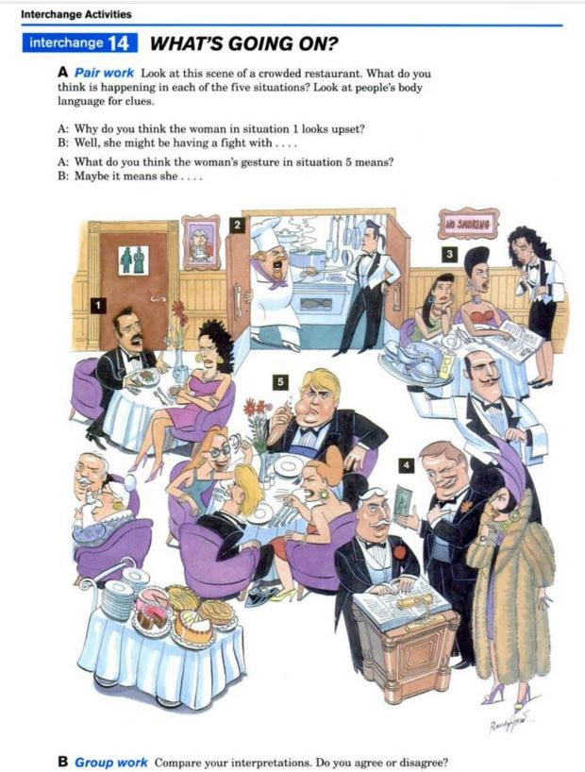

Source: Richards, J. C., Hull, J., & Proctor, S. (2005). Interchange: Student’s book. (3rd ed.) Cambridge, UK: Cambridge University Press.

