Bio-Data: Chesla Ann Lenkaitis [ORCID 0000-0002-3791-2180]

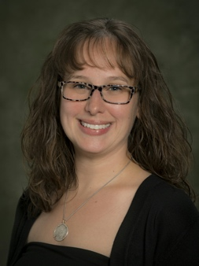
Chesla Ann Lenkaitis is an Assistant Professor of Spanish in the Department of Romance Languages at Binghamton University (Binghamton, New York, USA). Dr. Lenkaitis is the department’s language coordinator and the program coordinator of the Master of Arts in Teaching in French and Spanish Adolescence Education. She dedicates herself to teaching Spanish and identifying the most effective ways to facilitate the learning and teaching of a second language. Besides having published peer-reviewed journal articles and book chapters, she recently co-edited the book Engaging teacher candidates and language learners with authentic practice and joined the MEXTESOL Journal as an Assistant Editor.

Bio-Data: Shannon M. Hilliker

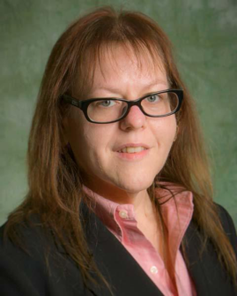
Shannon M. Hilliker received her PhD at the University at Albany in Curriculum and Instruction with a focus on language learning in 2007. She has been in the TESOL (Teaching English to Speakers of Other Languages) field since 1999 where she has taught in both ESL (English as a Second Language) and teacher education. Dr. Hilliker is an Assistant Professor of TESOL at Binghamton University (Binghamton, New York, USA). Her research interests include rural education, teacher professional development, elementary ESL after school programs, international student success and virtual exchange with both language learners and teacher candidates.

Bio-Data: Barbara Loranc-Paszylk [ORCID 0000-0003-2495-3482]

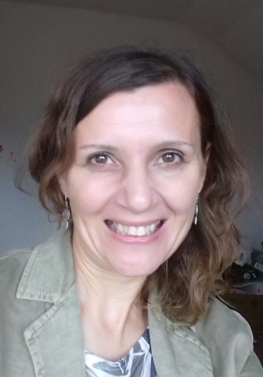
Barbara Loranc-Paszylk works as Assistant Professor at University of Bielsko-Biała, Poland. She holds a PhD in Applied Linguistics. Her research interests focus on exploring various aspects of content and language integrated learning (CLIL) as well as telecollaboration and innovative uses of digital resources in foreign languages teaching and learning. She has published in edited volumes and international journals of the fields of second language acquisition and computer assisted language learning.

