Biodata: Catalina Herrera Mateus, Ángela María Gamboa, Lady Viviana Cuervo, & Catalina de los Ángeles Lalle

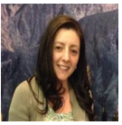
Ángela María Gamboa holds a Bachelor degree in Spanish and Foreign language teaching and a M.A degree in foreign language teaching from Universidad Pedagógica Nacional (Colombia). She has been a teacher for fourteen years, and she has experience in teaching English to students of different ages in language institutes, secondary and elementary education. In the last 7 years, she has worked in Bachelor programs to guide her students in the process of becoming future teachers. Currently, she is a professor and a researcher at La Salle University. Her academic interests include didactics, learning strategies, reflective practice and teachers' training.

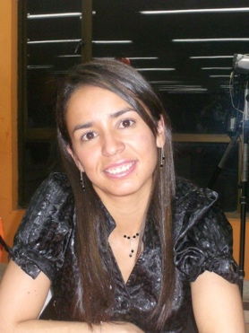
Catalina Herrera Mateus is a full- time professor and researcher at Corporación Universitaria Minuto de Dios. She holds a Bachelor degree in English language teaching from Universidad Distrital Francisco José de Caldas and a Master degree in Education from Universidad de los Andes. She has taught English in different institutions. Besides, she has broad experience as teacher trainer and research tutor. She is an expert in language teaching methodologies and language assessment Her current interests include research training, teachers’ beliefs, and reflective practice.

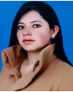
Lady Viviana Cuervo is an EFL teacher and researcher at La Salle University. She holds a Bachelor degree in Spanish, English and French from La Salle University and a M.A degree in English Language Teaching - Autonomous Learning Environments from Universidad de la Sabana. She has been a language teacher for 11 years in different contexts and populations, from kids to adults, mainly in bachelor programs. Her research interests involve materials design, methodology and didactics in ELT and technology in language teaching.

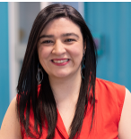
Catalina de los Ángeles Lalle holds a Bachelor degree in English as a foreign Language from Universidad Distrital, and a Master degree in education from Universidad de los Andes. She has worked as an EFL professor at several undergraduate programs, in Bogota for 10 years and currently in Czech Republic. She has broad experience teaching English to students of different ages and contexts. A versatile educator, expert in group work, planning, guiding-developing research projects, and solving problem approaches in English teaching, not only as a second but also as an international language in Universities as well as schools and specialized institutions.

