Appendix 2
What are cognates?
Two words in two languages that have a common origin. Cognates are often similar or identical in form. For example, the English "kiosk" and the Spanish quiosco are cognates because they both come from the Turkish kosk. They can also be words in two languages that are similar but have no common origin, such as the Spanish sopa (meaning "soup") and the English "soap."
Cognates often have a similar meaning, but in some cases the meaning is different. False cognates are cognates that have different meanings, such as the Spanish molestar (to bother) and the English "molest" (to abuse sexually). A more precise term to use for such word pairs is "false friends."
Taken from: http://spanish.about.com/cs/vocabulary/g/cognategloss.htm

Corpus Linguistics

What is a corpus?
A corpus is a collection of texts in an electronic database. It is a systematic, planned, and structured compilation of texts.

Description of our corpus
Name: Collins. The Bank of English
Size: The corpus contains 524 million words and it continues to grow with the constant addition of new material.
Form: Spoken and written language.
Free access!!!!

What are we going to look at?

Concordances:
Concordances are lists of words/sentences that can be used to examine the use and behaviour of words in their original context. They can help us distinguish the meanings of words.
Step 1. Go to: http://www.collins.co.uk/Corpus/CorpusSearch.aspx
Step 2. Type in the word you are looking for in the Type your query space, and select where you want to look for the word in the corpus:
- British books, ephemera, radio, newspapers, magazines (36 million words)
- American books, ephemera and radio (10 million words)
- British transcribed speech (10 million words)
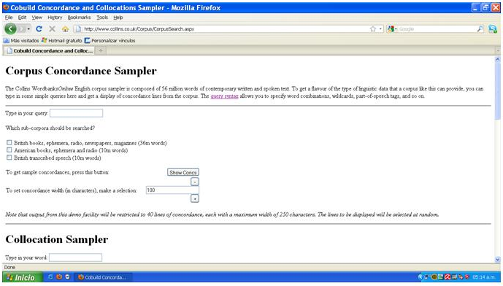

Example: the word actually was typed in the Type your query space, and the British books, ephemera, radio, newspapers, magazines option was chosen.
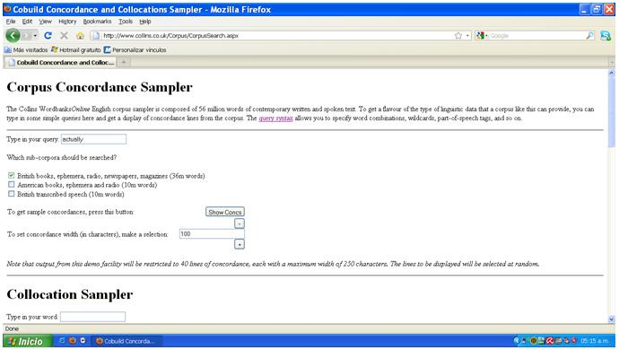

Step 3. Click on the Show Concs button to obtain your results:
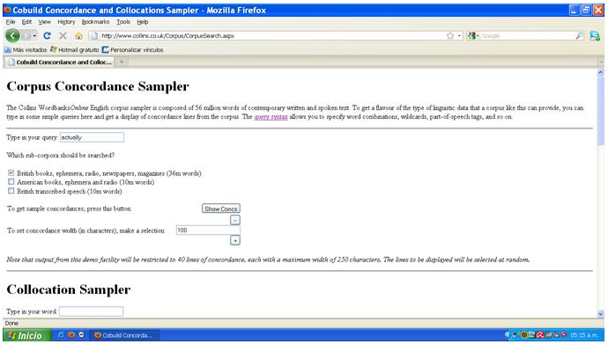

Step 4. A new window with your results will appear on the screen!!!! We’re ready to start analyzing!
