Biodata: Edward V. Campbell

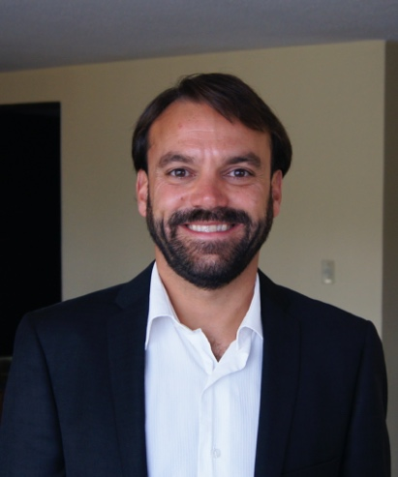
Edward V. Campbell is a professor in the School of Tourism and Geography of Huizhou University, China. Previously, he was a full-time professor and the undergraduate coordinator of the Department of Languages of the Universidad Autónoma del Estado de México, where he received his M.A. in English Education. He has taught English and related subjects to a wide variety of students in four countries: South Korea, Canada, Mexico, and China. His research interests include writing instruction, phonetics and phonology, language and culture, and literature.

